

Adding new table in Goldengate Process
SIT Environment

Project



DISCLAIMER

This document is strictly private, confidential and personal to its recipients and should not be copied, distributed or reproduced in whole or in part, nor passed to any third party.

Version history
Date | Version | Description | Author
2020-11-24 | 1.0 | Initial Version | Ajithraj Thangaraj

Contents
Version history 3
1. Introduction 5
2. Background info 5
3. Steps to Add Table in GG Process 5

Introduction

Oracle GoldenGate is a comprehensive software package for real-time data integration and replication. The product set enables high availability solutions, real-time data integration, transactional change data capture, data replication, transformations, and verification between operational and analytical enterprise systems. In this document, it has explained the step by step procedure to add the tables for replication in Goldengate process.

Background info

Operating System:
Linux
Version #1 SMP Tue May 26 15:05:43 EDT 2020, Release 3.10.0-1127.10.1.el7.x86_64
Node: e75lrl2038.lfnet.se
Machine: x86_64

Database:
Oracle Database 12c Enterprise Edition Release 12.1.0.2.0 - 64bit Production.

Steps to Add Table in GG process.

step 1:
log in source database
[grid@e75lrl2038 oggcore_1]$ ./ggsci
GGSCI (e75lrl2038.lfnet.se) 1> dblogin useridALIAS oggadmin
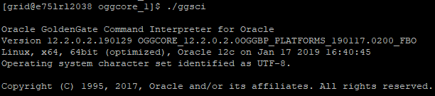

step 2:
add trandata
GGSCI (e75lrl2038.lfnet.se as ggadmin@SIT2) 2> add trandata INSIS_GEN_V10.CLAIM_INSPECTIONS
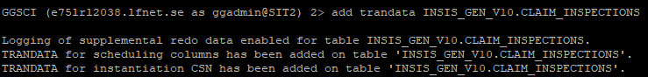

step 3
Add the new table in the INEDWTAB.OB file and this location can be found in extract parameter file INEDW.prm.
TABLE INSIS_GEN_V10.CLAIM_INSPECTIONS;
GGSCI (e75lrl2038.lfnet.se) 1> edit params INEDWTAB.OB
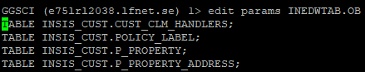
[grid@e75lrl1034 dirprm]$ cat INEDW.prm
EXTRACT INEDW
SETENV (ORACLE_HOME="/d01/database/oracle/app/oracle/product/12.1.0/dbhome_1")
SETENV (GRID_HOME='/d01/grid12.2')
SETENV (TNS_ADMIN = "/d01/grid12.2/network/admin")
UserIdAlias oggadmin
TRANLOGOPTIONS INTEGRATEDPARAMS (max_sga_size 1000, parallelism 1)
TranlogOptions CHECKPOINTRETENTIONTIME 10
FETCHOPTIONS FETCHPKUPDATECOLS
LOGALLSUPCOLS
NOTCPSOURCETIMER
EXTTRAIL /GGhome/GG_home/oracle/app/oracle/product/12.2.0/oggcore_1/dirdat/ie
ReportCount Every 30 minutes, Rate
ReportCount Every 10000 records
Report at 01:00
ReportRollOver at 01:15

STATOPTIONS REPORTFETCH
obey /GGhome/GG_home/oracle/app/oracle/product/12.2.0/oggcore_1/INEDWTAB.OB
TABLE INSIS_GEN_V10.GG_TEST,
TOKENS (
CAPGROUP = @GETENV ('GGENVIRONMENT', 'GROUPNAME'),
CAPTIME = @DATE ('YYYY-MM-DD HH:MI:SS.FFFFFF','JTS',@GETENV ('JULIANTIMESTAMP')),
EDMLDELTASTATS = @GETENV ('DELTASTATS', 'DML'),
PMPGROUP = @GETENV ('GGENVIRONMENT', 'GROUPNAME'),
PMPTIME = @DATE ('YYYY-MM-DD HH:MI:SS.FFFFFF','JTS',@GETENV ('JULIANTIMESTAMP'))
);
Step 4
Generate table(s) metadata of source table and create the table using metadata under INSISHIST schema
SQL> set lines 200
SQL> set pages 200
SQL> set long 10000
SQL> select dbms_metadata.get_ddl('TABLE','CLAIM_INSPECTIONS','INSIS_GEN_V10') from dual;
DDL for source table
DDL for target table
Step 5
Set default value of SRC_COMMIT_TS column in the newly created INSISHIST target table
ALTER TABLE INSISHIST.CLAIM_INSPECTIONS MODIFY SRC_COMMIT_TS DEFAULT to_date('1753-01-01','YYYY-MM-DD');

Step 6
Restart the Extract
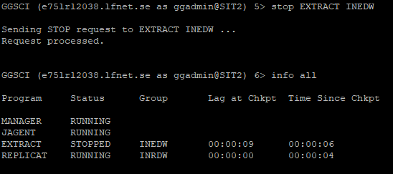
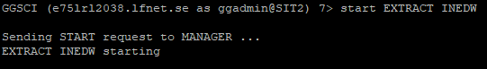
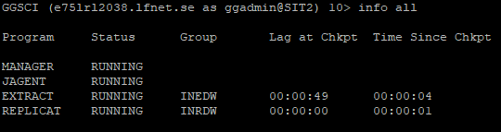

Step 7
Please note the FLASHBACK_SCN value and take data pump export of the source table(s) and import into the target INSISHIST table(s).
SQL> select to_char(current_scn) from v$database;
TO_CHAR(CURRENT_SCN)
----------------------------------------
41393959646

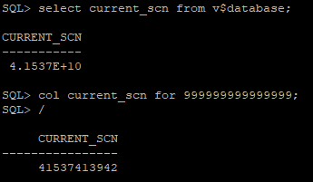

expdp \'/as sysdba\' DIRECTORY=DATA_PUMP_DIR dumpfile=Add_GG_tables.dmp flashback_scn=41537413942 tables=INSIS_GEN_V10.CLAIM_INSPECTIONS logfile=Export_GG_tables_Nov12.log

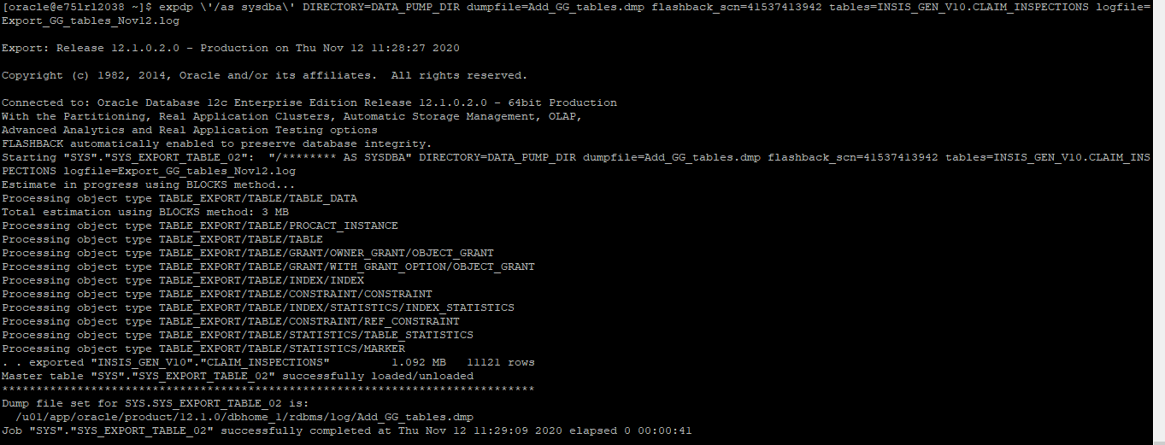
impdp \'/as sysdba\' DIRECTORY=DATA_PUMP_DIR dumpfile=Add_GG_tables.dmp remap_schema=INSIS_GEN_V10:INSISHIST logfile=Import_GG_tables_Nov12.log content=DATA_ONLY TABLE_EXISTS_ACTION=TRUNCATE

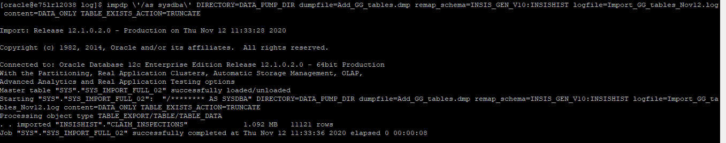

Step 8
Rename the target table name and remove the default value as INSISHIST user.
SQL> conn INSISHIST/********
Connected.
SQL> alter table CLAIM_INSPECTIONS rename to IGV_CLAIM_INSPECTIONS;
SQL> ALTER TABLE IGV_CLAIM_INSPECTIONS MODIFY SRC_COMMIT_TS DEFAULT null;

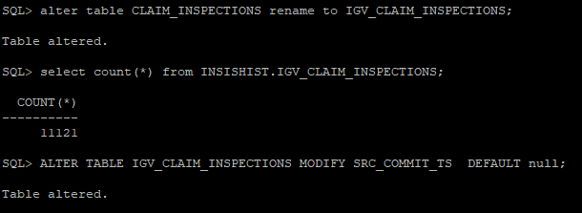

Step 9
Here’s the important step, you need to edit the replicat’s parameter file and include the following string in the map statement.
GGSCI (e75lrl2038.lfnet.se) 2> edit params INRDWTAB.OB

MAP INSIS_GEN_V10.CLAIM_DOCLAD TARGET INSISHIST.IGV_CLAIMDOCLAD , COLMAP ( USEDEFAULTS, db_op_type = @GETENV ('GGHEADER', 'OPTYPE'), src_commit_ts = @GETENV ('GGHEADER','COMMITTIMESTAMP'), bfr_aft_ind = @GETENV ('GGHEADER','BEFOREAFTERINDICATOR'), GG_CSN = @GETENV ('TRANSACTION','CSN'), GG_TFILE_SEQNO = @COMPUTE(@NUMSTR(@GETENV('RECORD','FILESEQNO'))*1), GG_TFILE_RBA = @GETENV('RECORD','FILERBA'));
[grid@e75lrl1034 dirprm]$ cat INRDW.prm
MACRO #exception_handler
BEGIN
, TARGET ggadmin.exceptions_others
, COLMAP (rep_name = 'INRDW'
, table_name = @GETENV ('GGHEADER', 'TABLENAME')
, errno = @GETENV ('LASTERR', 'DBERRNUM')
, dberrmsg = @GETENV ('LASTERR', 'DBERRMSG')
, optype = @GETENV ('LASTERR', 'OPTYPE')
, errtype = @GETENV ('LASTERR', 'ERRTYPE')
, logrba = @GETENV ('GGHEADER', 'LOGRBA')
, logposition = @GETENV ('GGHEADER', 'LOGPOSITION')
, filenum = @GETENV ('RECORD', 'FILESEQNO')
, filerba = @GETENV ('RECORD', 'FILERBA')
, committimestamp = @GETENV ('GGHEADER', 'COMMITTIMESTAMP')
, resolution_required = 'Y')
, INSERTALLRECORDS
, EXCEPTIONSONLY;
END;
-- End of Macro
replicat INRDW
SETENV (ORACLE_HOME="/d01/database/oracle/app/oracle/product/12.1.0/dbhome_1")
SETENV (GRID_HOME="/d01/grid12.2")
SETENV (TNS_ADMIN = "/d01/grid12.2/network/admin")
REPERROR (DEFAULT, EXCEPTION)
REPERROR (DEFAULT2, EXCEPTION)
REPERROR (-1, EXCEPTION)
discardfile /GGhome/GG_home/oracle/app/oracle/product/12.2.0/oggcore_1/dirdsc/INRDW.dsc, purge
DBOPTIONS ENABLE_INSTANTIATION_FILTERING
UserIdAlias oggadmin
--sourcedefs /GGhome/GG_home/oracle/app/oracle/product/12.2.0/oggcore_1/dirdef/INSISTABLEDEFINITION.DEF
GETUPDATEBEFORES
INSERTALLRECORDS
INSERTUPDATES
ReportCount Every 30 minutes, Rate
ReportCount Every 10000 records
Report at 01:00
ReportRollOver at 01:15
OBEY INRDWTAB.OB
MAP INSIS_GEN_V10.GG_TEST, TARGET INSISHIST.GG_TEST_HIST, KEYCOLS (REP_NAME) ,
COLMAP ( USEDEFAULTS,
EXT_NAME = @TOKEN ('CAPGROUP'),
CAPTIME = @TOKEN ('CAPTIME'),
PMP_NAME = @TOKEN ('PMPGROUP'),
PMPTIME = @TOKEN ('PMPTIME'),
REP_NAME = @GETENV ('GGENVIRONMENT', 'GROUPNAME'),
REPTIME = @DATE ('YYYY-MM-DD HH:MI:SS.FFFFFF','JTS',@GETENV ('JULIANTIMESTAMP')),
EDMLDELTASTATS = @TOKEN ('EDMLDELTASTATS'),
RDMLDELTASTATS = @GETENV ('DELTASTATS', 'DML'),
db_op_type = @GETENV ('GGHEADER', 'OPTYPE'),
src_commit_ts = @GETENV ('GGHEADER','COMMITTIMESTAMP'),
bfr_aft_ind = @GETENV ('GGHEADER','BEFOREAFTERINDICATOR'),
GG_CSN = @GETENV ('TRANSACTION','CSN'),
GG_TFILE_SEQNO = @COMPUTE(@NUMSTR(@GETENV('RECORD','FILESEQNO'))*1),
GG_TFILE_RBA = @GETENV('RECORD','FILERBA'));
-- All other conflicts are reported to a generic exceptions table
MAP *.* #exception_handler();
Step 10
Restart the Replicat

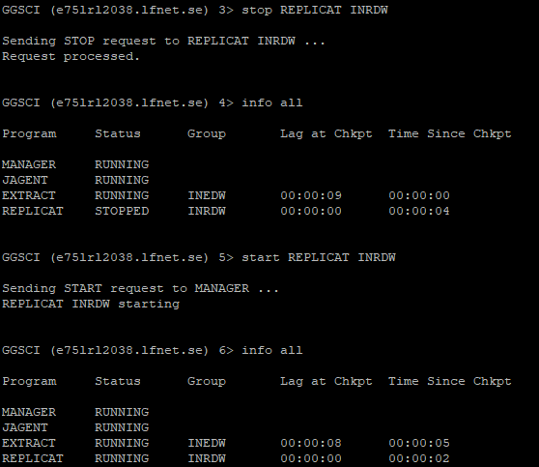

END OF DOCUMENT

